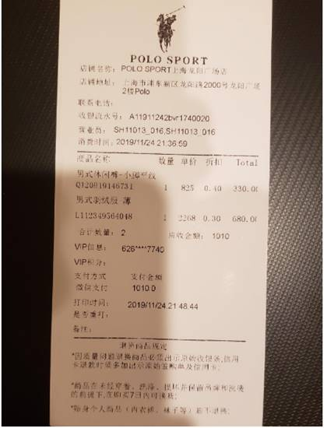 | POLO SPORT  Store Name: POLO SPORT Shanghai Longyang Plaza Store  Store Address: Polo 2F Longyang Plaza, Longyang Road 2000, Pudong Xin District, Shanghai  Phone:  Cashier Serial No.: A11911242bY1740020  Salesperson: SH11013016SH11013 016  Purchase Time: 2019/11/24 21.36.69  Product Name Quantity Unit Price Discount Total  Men’s casual pants  Q12019146731 1 825 0.40 330.00  Men’s down jacket  L112349564048 1 2268 0.30 680.00  Total Quantity : 2 Amount Receivable: 1010  VIP Info: 626****7740  VIP Points:  Payment Method Amount Paid  WeChat Payment 1010.0  Printed: 2019/11/24 21:48:44  Memo  Rules for Return and Exchange of Goods  * The original cashier slip must be presented for returned goods due to quality problems. In case of credit card returned goods, signed purchase order and credit card must be presented.  2. Items can be returned and exchanged within 7 days after purchase, provided that the products are not used, washed, modified, damaged, and the tag and washing mark are kept intact.  3. Personal clothing (underwear, socks, etc.) cannot be returned or exchanged.

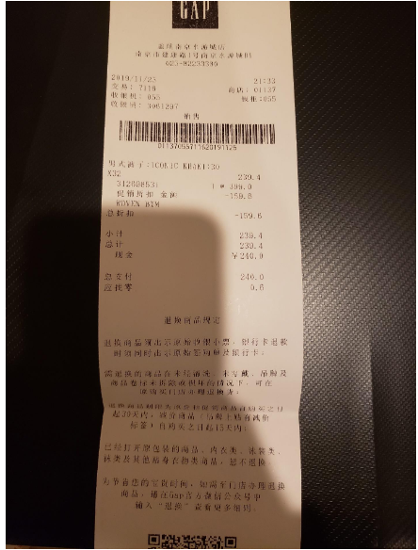 | GAP Nanjing Aquatic City Store  B1, Jiankang Road,Nanjing  025-82233380  2019/11/23 21:33  Transaction: 7118 Store: 01137  Cash Register: 054 Locker: 065  Cashier: 3061297  Sales  Bar Code Image  01137055711620191125  Men's Trousers： (Illegible)  X32 239.4  307119229 399.0  Promotion Discount Amount -159.6  RDVEN BIM  Total Amount -159.6  Subtotal 239.4  Total 239.4  Cash ¥240.0  Account: 9542  Authorization: 9 (M)  Total Payment 240.0  Change 0.6  Rules for Return and Exchange of Goods  The original cashier slip must be presented for returned goods. In case of bank card returned goods, both signed purchase order and bank card must be presented.  Items can be returned and exchanged at the store you made the purchase, provided that the products are not used, washed, modified, damaged, and the tag and washing mark are kept intact.  Non-discount items can be returned and exchanged within 30days starting from your purchase day, and discounted items within 15 days starting from your purchase day.  Underwear, swimwear, hosiery and other intimate clothing products cannot be returned or exchanged.  In order to save your precious time, if you need to go to the store to handle the return and exchange of goods, please enter "return and exchange" in the GSP official WeChat account to see more details.

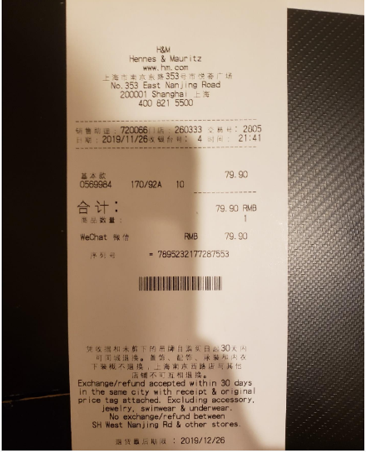 | H&M  Hennes & Meuritz  www.hm.com  No.352 East Nanjing Road  200001 Shanghai  400 821 5500  Sales Person 720066 Store No. 260333 Transaction No.: 2805  Date: 2019/11/26 Counter No.: 4 Time: 21:41  Basic Version 79.90  0569984 170/92A 10  -----------------------------  Total: 79.90 RMB  Item Quantity 1  WeChat Payment RMB 79.90  Serial No. *7895232177287553  Exchange/refund accepted within 30 days in the same city with receipt & original price tag attached. Excluding accessory, jewelry, swimwear & underwear.  No exchange / refund between  SH West Nanjing Rd & other stores.  Refund deadline: 2019/12/26

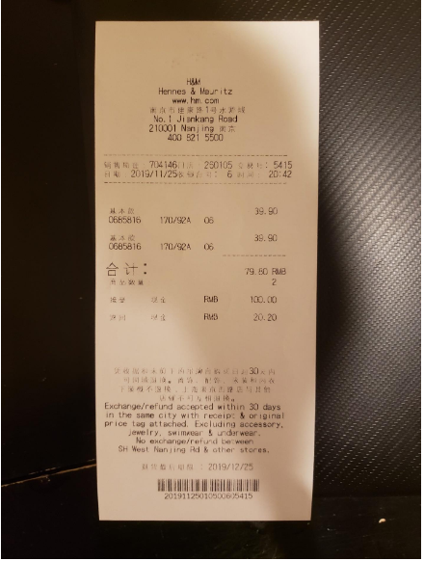 | H&M  Hennes & Meuritz  www.hm.com  No.352 East Nanjing Road  200001 Shanghai  400 821 5500  Sales Person 704146 Store No. 250105 Transaction No.: 5415  Date: 2019/11/25 Counter No.: 6 Time: 20:42  Basic Version 39.90  0685816 170/92A 06  Basic Version 39.90  0685816 170/92A 06 -----------------------------  Total: 79.90 RMB  Item Quantity 2  Paid Cash RMB 79.90  Change Cash RMB 20.20  Exchange/refund accepted within 30 days in the same city with receipt & original price tag attached. Excluding accessory, jewelry, swimwear & underwear.  No exchange / refund between  SH West Nanjing Rd & other stores.  Refund deadline: 2019/12/25  20191125010500625415

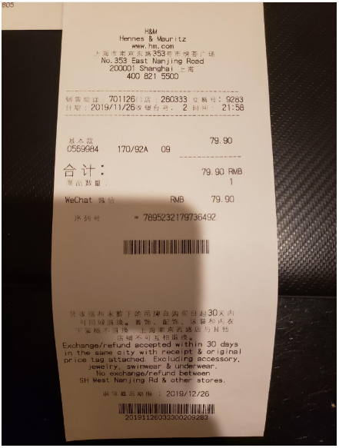 | H&M  Hennes & Meuritz  www.hm.com  No.352 East Nanjing Road  200001 Shanghai  400 821 5500  Sales Person 701126 Store No. 260333 Transaction No.: 9283  Date: 2019/11/26 Counter No.: 2 Time: 21:58  Basic Version 79.90  0569984 170/92A 09  -----------------------------  Total: 79.90 RMB  Item Quantity 1  WeChat Payment RMB 79.90  Serial No. *7895232179736492  Exchange/refund accepted within 30 days in the same city with receipt & original price tag attached. Excluding accessory, jewelry, swimwear & underwear.  No exchange / refund between  SH West Nanjing Rd & other stores.  Refund deadline: 2019/12/26  20191126033300209283

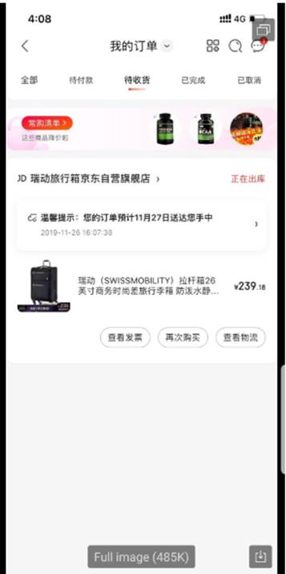 | 4:08 4G  My Orders  All To be paid To be received Completed Canceled  Frequent Purchase List  The prices of these items have been dropped  JD Ruidong Suitcase Jingdong Self-operated Flagship Store Preparing for shipment  Tips: Your order is scheduled to reach your hand by November 27.  2019-11-26 16:07:38  View invoices Buy again View logistics
  Ruidong(SWISSMOBILITY) Trolley Case 26-inch Business Fashion Travel Suitcase Waterproof | ¥ 239.18

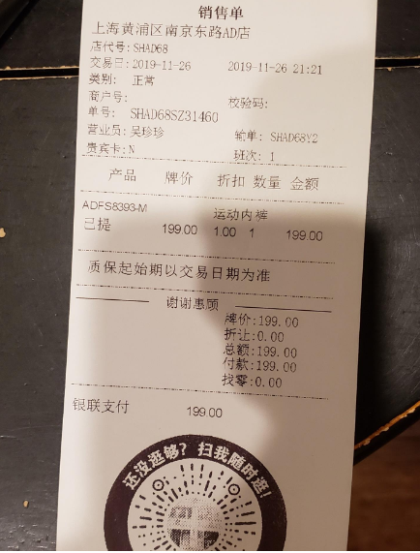 | Sales Slip  AD Store Nanjing Dong Road, Huangpu District, Shanghai  Store Code: SHAD68  Transaction Date: 2019-11-26 2019-11-26 21:21  Type: Normal  Business Number: Check Code:  Slip No. SHAD68SZ31460  Sales Person: Wu Zhenzhen Data Entry: SHAD68Y2  VIP Card: N Shift No.: 1  --------------------------------------------------------------------------------------------  Product Price Discount Quantity Amount  ADFS8393-M Sports Underwear  Delivered 199.00 1.00 1 199.00  --------------------------------------------------------------------------------------------  Quality assurance starts from the transaction date  -------------------------Thank you for your patronage-------------------------  Price: 199.00  Discount: 0.00  Amount: 199.00  Paid: 199.00  Change: 0.00  UnionPay Payment 199.00  Do you still want to shop around? Scan me and continue your journey!

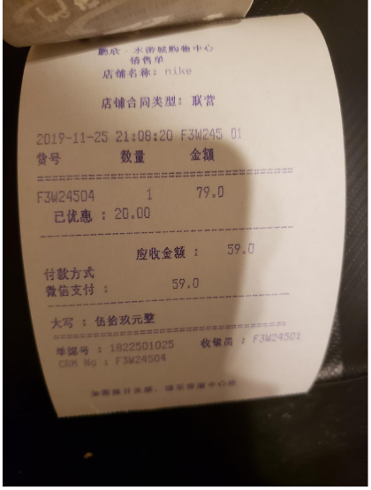 | Pengxin Aquatic City Store  Sales Slip: nike  Store Contract Type: Joint venture  2019-11-25 21:08:20 F3W245 01  Item No. Quantity Amount  F3M2454 1 79.0  Discounted amount: 20.00  Amount Receivable: 59.0  Payment Method  WeChat Payment: 59.0  ----------------------------------------------------------------------------------------  Chinese Numerals: fifty-nine yuan  Receipt No.: 1822501025 Cashier: F3M24501  CRM No.: F3M24504  To request a fapiao, please go to the customer service center.

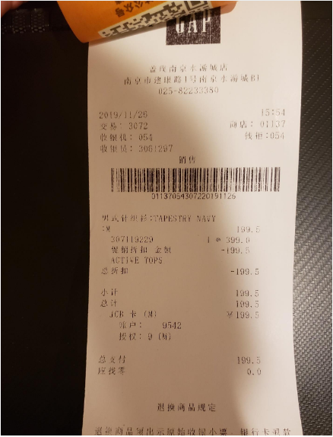 | GAP Nanjing Aquatic City Store  B1, Jiankang Road,Nanjing  025-82233380  2019/11/26 15:54  Transaction: 3072 Store: 01137  Cash Register: 054 Locker: 054  Cashier: 3061297  Sales  Bar Code Image  01137054307220191126  Men's Knitwear： TAPETRY NAVY  :M 199.5  307119229 399.0  Promotion Discount Amount -199.5  ACTIVE TOPS  Total Amount -199.5  Subtotal 199.5  Total 199.5  JCB Card(M) 199.5  Account: 9542  Authorization: 9 (M)  Total Payment 199.5  Change 0.0  Rules for Return and Exchange of Goods  * The original cashier slip must be presented for returned goods. In case of credit card returned goods,

